**9 SCIENCE BIOLOGICAL CONTROL ASSIGNMENT 2015**

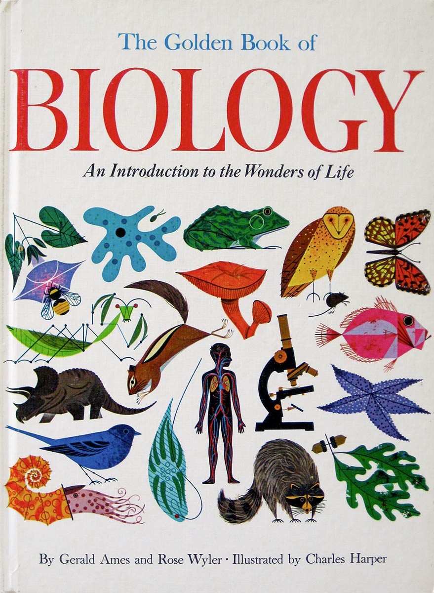

Name: _______________________ Teacher: __________________

Form: _____________________ Due date: _________________

**Aim:** This assignment will allow you to find out about biological controls used in Australia.

**Plagiarism**

🞟 This assignment is to be done individually, not with a partner.

🞟 You must write in your own words not copy sentences word for word from another student or

another source.

🞟 Plagiarising = instant zero on assignment and you will have to re-do it.

**Assessment policy**

Have sick note/legitimate reason from parent = new negotiated due date.

Assignment not submitted on due date and no sick note from parents = -20% mark

Assignment not submitted on new negotiated due date = -40% mark

+ Letter home to parents.

+ Must attend academic completion to complete assignment.

**OR**

Submit assignment to student services before academic completion date and academic completion not necessary.

Academic completion not attended = zero on assignment + Saturday detention.

If you know that you cannot submit your assignment on the due date, let your teacher know **BEFORE** the due date (email them if you are not in school) or just email them your assignment the night before.

**Assignment requirements**

You will hand in two things:

➀ This assignment booklet with the completed reference list and attached notes.

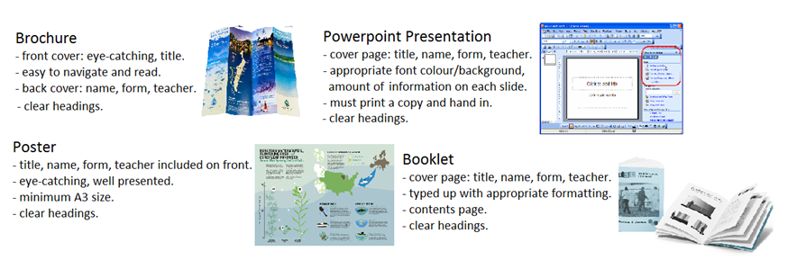➁ Your report in one of the following forms.

**9 SCIENCE BIOLOGICAL CONTROL ASSIGNMENT 2015**

Choose a biological control that was introduced in Australia from the list below.

*(If you would like to research a different biological control, check with your teacher first).*

🞟Cane toad 🞟myxomatosis 🞟calicivirus

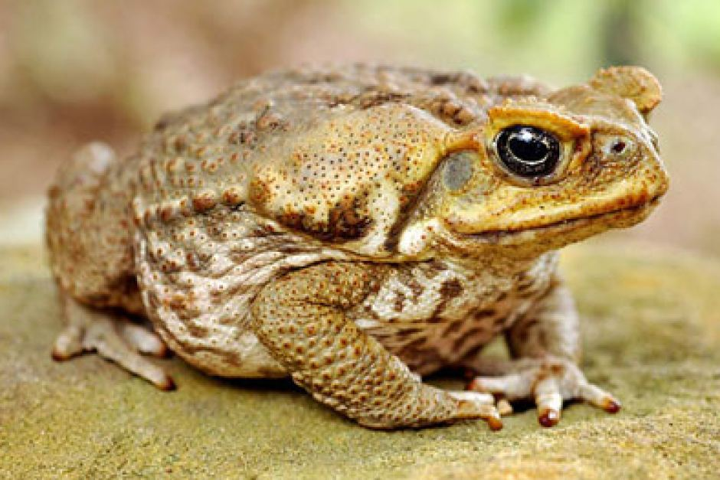

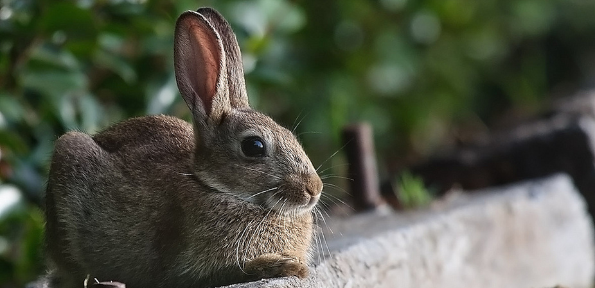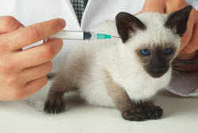

*Include the following information in your assignment:*

1. Name of your chosen biological control.

2. State where the biological control is originally from, where it is naturally found in the world.

3. Explain what led scientists to investigate this particular biological control in Australia – what were they trying to combat?

(Minimum one paragraph).

4. Look at what research was done and what led scientists to believe that it was a good idea to use this biological control.

(Minimum one paragraph).

5. Explain whether you think that there were any issues with the scientists’ scientific method (aim, hypothesis, method etc.) in regards to introducing this biological control.

(Minimum one paragraph).

6. Compare the positives and negatives of introducing this biological control in Australia (ecological impact).

(Minimum two positives and two negatives).

**Reference list**

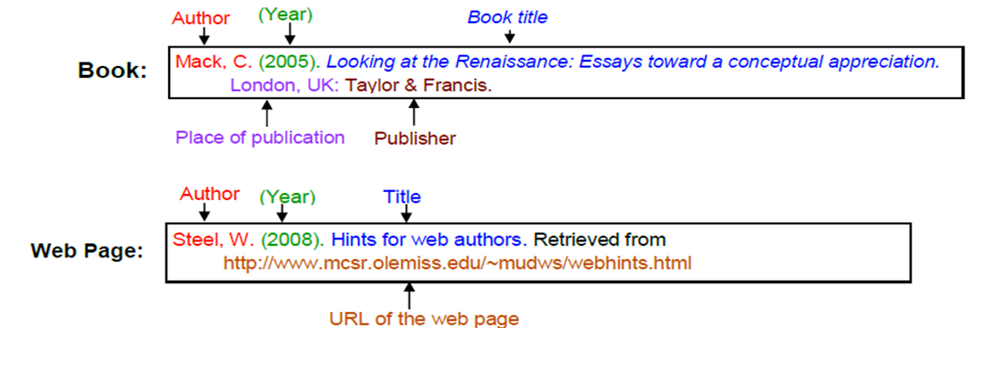Referenced using the style below (pg. 180 of your diary has more information).

_________________________________________________________________________________________________

_________________________________________________________________________________________________

_________________________________________________________________________________________________

_________________________________________________________________________________________________

_________________________________________________________________________________________________

_________________________________________________________________________________________________

_________________________________________________________________________________________________

_________________________________________________________________________________________________

_________________________________________________________________________________________________

_________________________________________________________________________________________________

_________________________________________________________________________________________________

_________________________________________________________________________________________________

_________________________________________________________________________________________________

_________________________________________________________________________________________________

_________________________________________________________________________________________________

_________________________________________________________________________________________________

_________________________________________________________________________________________________

_________________________________________________________________________________________________

_________________________________________________________________________________________________

_________________________________________________________________________________________________

_________________________________________________________________________________________________

**Marking key**

|  |  |  |  |
| --- | --- | --- | --- |
| **Content** | **Description** |  | **Your**  **mark** |
| Research | Origin of biological control (where did it originally come from?)  What led scientists to investigate the biological control, what were they trying to combat?  Research that has been done, what led scientists to believe it was a good idea to use the  biological control.  Explain issues with scientists’ scientific method.  Two positives of introducing the biological control.  Two negatives of introducing the biological control. | 2  2  3  2  4  4 |  |
| Referencing | Minimum of two references.  Minimum of two sources.  Referenced in correct format. | 2 |  |
| Presentation | Appropriate title, name, form, teacher, clear headings included on report.  Appropriate images or diagrams (must be referred to in text).  Has used scientific language.  Correct spelling.  Correct grammar.  Well formatted (appropriate font, font size, layout etc).  Must hand in notes. | 4 |  |
| **Total mark** | | 23 |  |

Mark as percentage: %

Teacher’s comments:

_________________________________________________________________________________________________

_________________________________________________________________________________________________

_________________________________________________________________________________________________

_________________________________________________________________________________________________

_________________________________________________________________________________________________